**Установка Hadoop/Hive и подготовка данных источника**

* Установка docker-container

docker-compose up -d

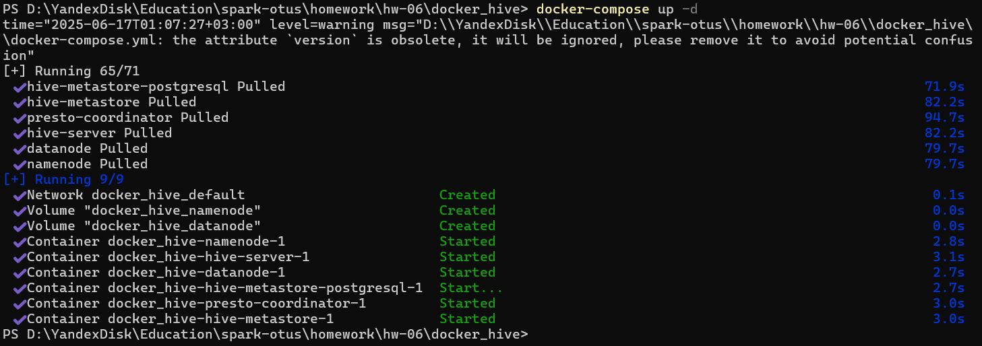

* Копирование данных с Kaggle

mkdir -p data

cd data

curl -L -o flights-and-airports-data.zip "https://www.kaggle.com/api/v1/datasets/download/tylerx/flights-and-airports-data"

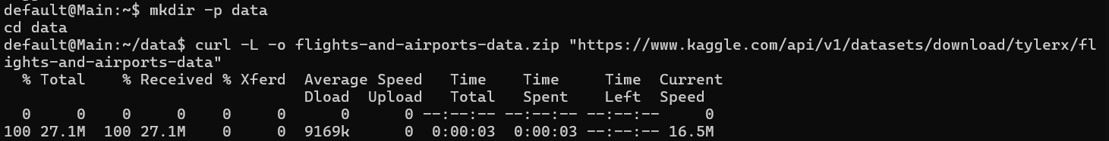

* Распаковка архива

unzip flights-and-airports-data.zip

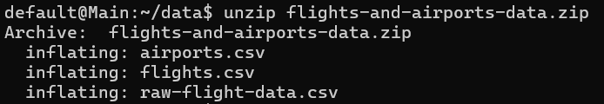

* Исправление кавычек в файлах

sed -i 's/"/@/g' airports.csv

sed -i 's/"/@/g' flights.csv

sed -i 's/"/@/g' raw-flight-data.csv

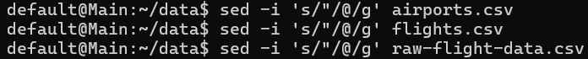

* Копирование файлов в контейнер namenode

docker cp airports.csv 1cb4c5799700:/tmp/

docker cp flights.csv 1cb4c5799700:/tmp/

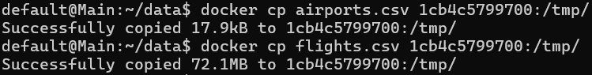

* Создание директорий в HDFS

docker exec -it 1cb4c5799700 bash

hdfs dfs -mkdir -p /user/hive/warehouse/flight_analysis.db/airports

hdfs dfs -mkdir -p /user/hive/warehouse/flight_analysis.db/flights



* Загрузка данных в HDFS

hdfs dfs -put /tmp/airports.csv /user/hive/warehouse/flight_analysis.db/airports/

hdfs dfs -put /tmp/flights.csv /user/hive/warehouse/flight_analysis.db/flights/



* Создание БД

**create** **database** **if** **not** **exists** src;

**create** **database** **if** **not** **exists** ods;

**create** **database** **if** **not** **exists** dm;

**Создание таблиц слоя SRC (слой источника)**

* Создание таблицы «src.airports»

**CREATE** **EXTERNAL** **TABLE** src.airports (

airport_id **INT**,

city **STRING**,

state **STRING**,

name **STRING**

)

**ROW** FORMAT DELIMITED

FIELDS TERMINATED **BY** ','

STORED **AS** TEXTFILE

LOCATION '/user/hive/warehouse/flight_analysis.db/airports'

TBLPROPERTIES (**"skip.header.line.count"**=**"1"**);

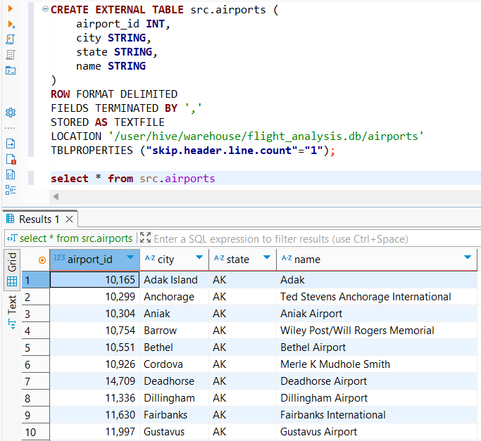

* Создание таблицы «src.flights»

**CREATE** **EXTERNAL** **TABLE** src.flights (

day_of_month **INT**,

day_of_week **INT**,

carrier **STRING**,

origin_airport_id **INT**,

dest_airport_id **INT**,

dep_delay **INT**,

arr_delay **INT**

)

**ROW** FORMAT DELIMITED

FIELDS TERMINATED **BY** ','

STORED **AS** TEXTFILE

LOCATION '/user/hive/warehouse/flight_analysis.db/flights'

TBLPROPERTIES (**"skip.header.line.count"**=**"1"**);

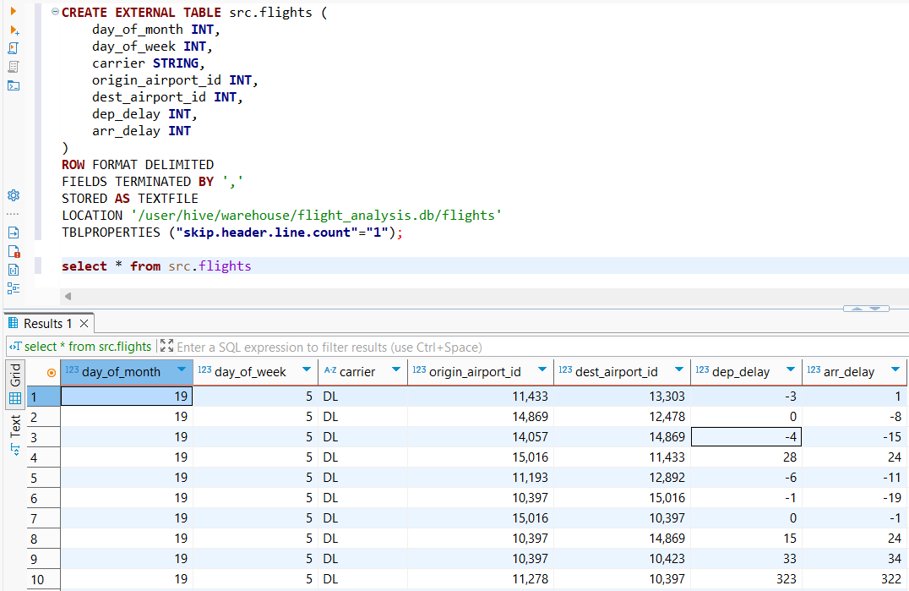

**Создание таблиц слоя ODS (слой сырых данных)**

* Создание таблицы «ods.airports»

**CREATE** **TABLE** ods.airports

(

airport_id **INT**,

city **STRING**,

state **STRING**,

name **STRING**

)

stored **as** orc;

**insert** overwrite **table** ods.airports

**select** airport_id, city, state, name **from** src.airports;

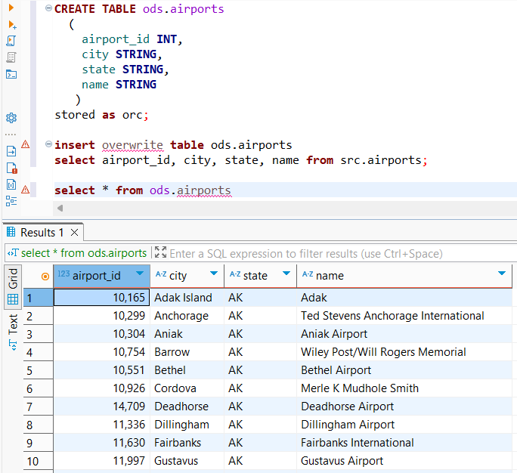

* Создание таблицы «ods.flights»

**CREATE** **TABLE** ods.flights (

day_of_month **INT**,

day_of_week **INT**,

carrier **STRING**,

origin_airport_id **INT**,

dest_airport_id **INT**,

dep_delay **INT**,

arr_delay **INT**

)

stored **as** orc;

**insert** overwrite **table** ods.flights

**select** day_of_month, day_of_week, carrier, origin_airport_id, dest_airport_id, dep_delay, arr_delay

**from** src.flights;

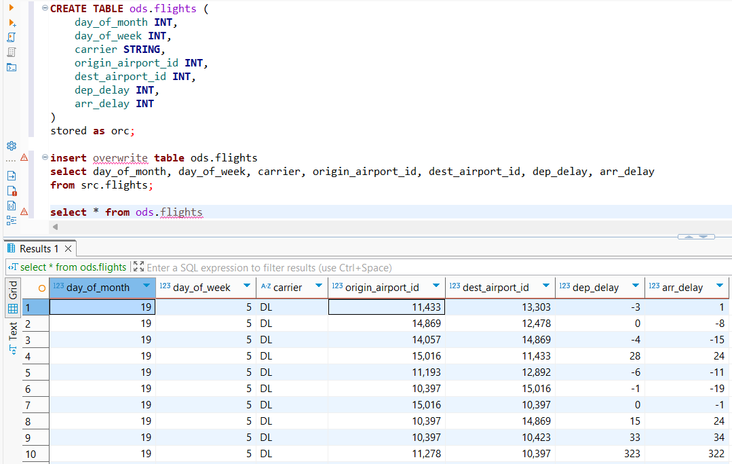

**Создание витринного слоя DM**

* Создание витрины с количеством рейсов по авиакомпаниям

**CREATE** **TABLE** dm.airline_flight_counts (

carrier **string**,

flight_count **bigint**

)

stored **as** orc;

**insert** overwrite **table** dm.airline_flight_counts

**SELECT**

carrier,

**COUNT**(*) **as** flight_count

**FROM**

ods.flights

**GROUP** **BY**

carrier

**ORDER** **BY**

flight_count **DESC**;

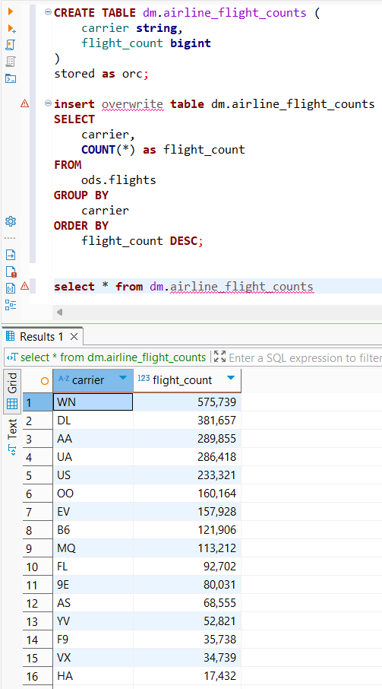

* Создание витрины со средней задержкой по аэропортам отправления

**CREATE** **TABLE** dm.avg_departure_delay_by_airport

(

airport_id **int**,

airport_name **string**,

city **string**,

avg_dep_delay **decimal**

)

stored **as** orc;

**insert** overwrite **table** dm.avg_departure_delay_by_airport

**SELECT**

a.airport_id,

a.name **as** airport_name,

a.city,

**AVG**(f.dep_delay) **as** avg_dep_delay

**FROM**

ods.flights f

**INNER** **JOIN**

ods.airports a **ON** f.origin_airport_id = a.airport_id

**GROUP** **BY**

a.airport_id, a.name, a.city

**ORDER** **BY**

avg_dep_delay **DESC**;

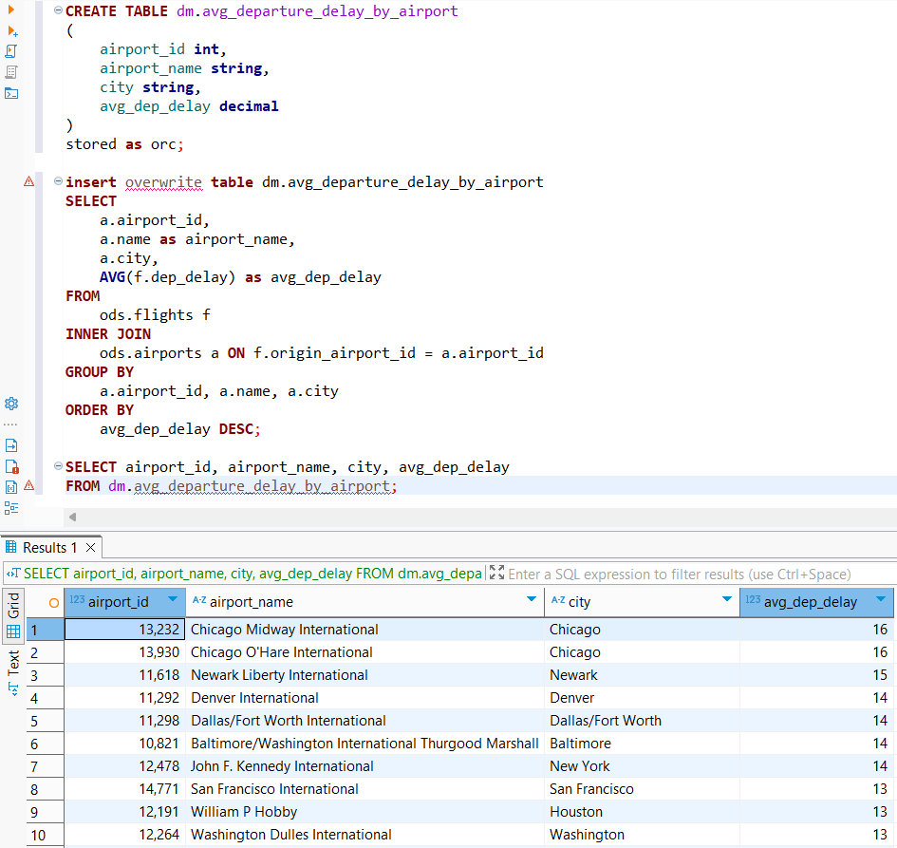

* Создание витрины с 10-ю самых популярных маршрутов

**CREATE** **TABLE** dm.popular_routes

(

origin_airport **string**,

dest_airport **string**,

flight_count **bigint**

)

stored **as** orc;

**insert** overwrite **table** dm.popular_routes

**SELECT**

a1.name **as** origin_airport,

a2.name **as** dest_airport,

**COUNT**(*) **as** flight_count

**FROM**

ods.flights f

**INNER** **JOIN**

ods.airports a1 **ON** f.origin_airport_id = a1.airport_id

**INNER** **JOIN**

ods.airports a2 **ON** f.dest_airport_id = a2.airport_id

**GROUP** **BY**

a1.name, a2.name

**ORDER** **BY**

flight_count **DESC**

LIMIT 10;

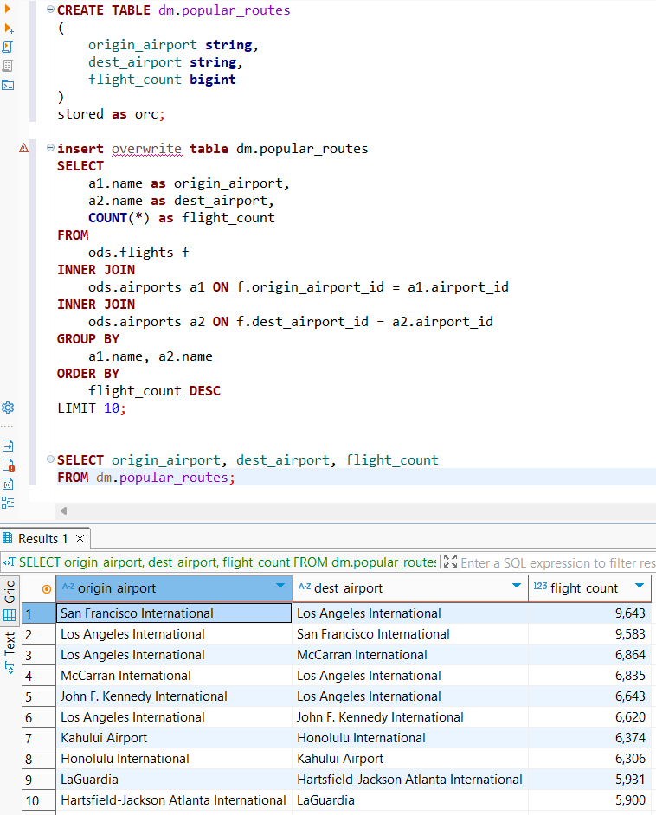

* Создание витрины с авиакомпаниями, к которых наибольшие задержки

**CREATE** **TABLE** dm.airlines_with_delays

(

carrier **string**,

avg_dep_delay **decimal**,

avg_arr_delay **decimal**,

total_flights **bigint**

)

stored **as** orc;

**insert** overwrite **table** dm.airlines_with_delays

**SELECT**

carrier,

**AVG**(dep_delay) **as** avg_dep_delay,

**AVG**(arr_delay) **as** avg_arr_delay,

**COUNT**(*) **as** total_flights

**FROM**

ods.flights

**GROUP** **BY**

carrier

**HAVING**

**AVG**(dep_delay) > 0

**ORDER** **BY**

avg_dep_delay **DESC**;

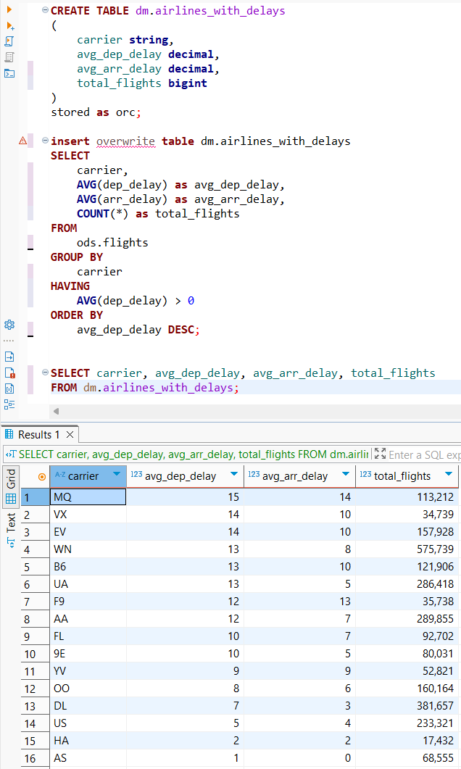

* Создание витрины с задержками по дням недели

**CREATE** **TABLE** dm.delays_by_weekday

(

day_of_week **int**,

avg_dep_delay **decimal**,

avg_arr_delay **decimal**,

total_flights **bigint**

)

stored **as** orc;

**insert** overwrite **table** dm.delays_by_weekday

**SELECT**

day_of_week,

**AVG**(dep_delay) **as** avg_dep_delay,

**AVG**(arr_delay) **as** avg_arr_delay,

**COUNT**(*) **as** total_flights

**FROM**

ods.flights

**GROUP** **BY**

day_of_week

**ORDER** **BY**

day_of_week;

